Player Name: ___________________________________________ Team Name: _________________________________
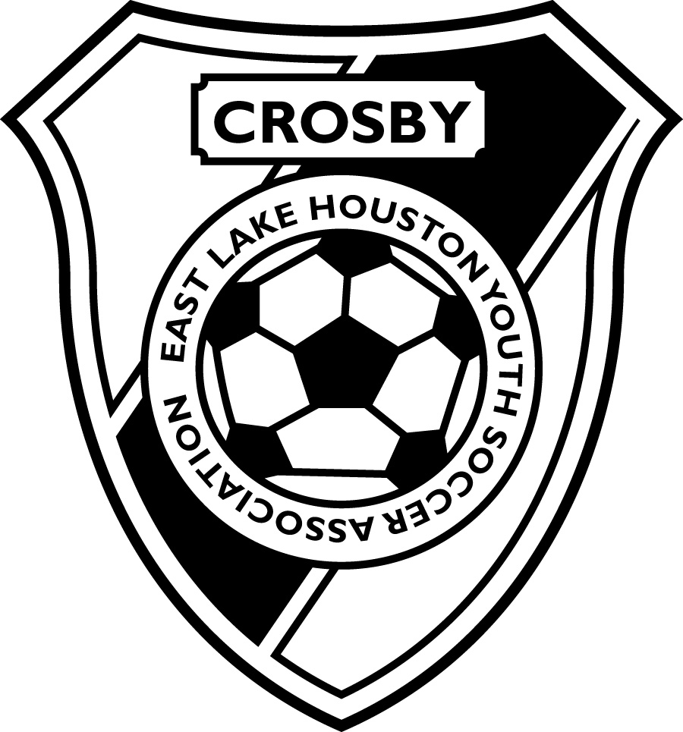

The youth soccer programs provided by Crosby Youth Soccer Club a subsidiary of
East Lake Houston Youth Soccer Association for Boys and Girls ages 4 through 17 in Crosby / Huffman/ Highlands/ Dayton/ Baytown/ Liberty/ Barber’s Hill and surrounding communities would not be possible without your financial support.
Your contribution will be used to defray the cost of field maintenance and supplies.

Have FUN, LEARN, GROW… TOGETHER!

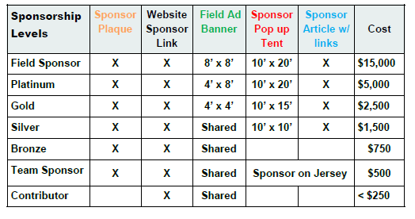
Please Circle Your Chosen Level of Sponsorship

Sponsor Information

Company Name:

Contact Name:

Phone:
Address:
E-mail:

Sponsorship Level:

Flat Donation: _______________________

Website URL: _______________________________

